**Puppy Pals**

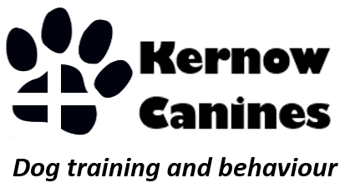

* **Never had a dog before?**
* **Been a while since you had a puppy?**
* **Experienced owner but want to make sure you get it right introducing a new puppy to the family?**

**Puppy Pals is designed to provide all the information you need to help choose the best dog breed for your family and lifestyle – exercise needs, grooming needs, behaviour traits, health concerns and much more.**

**I can help get your home and garden puppy ready and advise on crate training, nutrition, appropriate toys and training aids, and veterinary needs.**

**I offer one to one training at your home before your puppy’s vaccination course is complete to get you started, then follow up with group or one to one puppy classes to complement your vet’s puppy parties.**

**Ongoing support, help and individual training is available if needed.**

**I have over 15 years' experience as a registered veterinary nurse focusing on training and behaviour. During this time, I have seen so many dogs with issues that could have been avoided with appropriate training and help early on, and my aim with Puppy Pals is to help prevent this in the future.**

**Puppy packages available or bespoke plans can be tailored to your requirements.**

**Please contact Marie to discuss your needs. Kernow Canines 07538004609** [**kernowcanines@yahoo.com**](mailto:kernowcanines@yahoo.com)

**www.kernowcanines.com**

